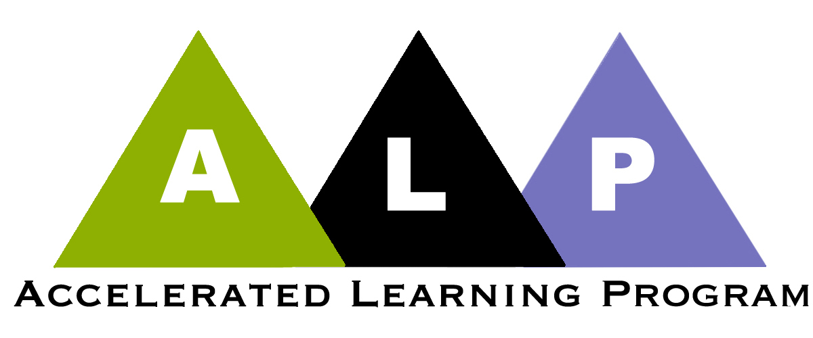
Sample Syllabus Sequencing Developmental and Comp Courses
SW = short writing
discussion = the class as a whole discusses something
group activity = the class is divided into smaller groups that work on something
EX = exercise

 | Credit-Level Comp | Developmental ALP  (The developmental ALP class always starts with a discussion of any questions left over from comp. In some cases this discussion may completely supplant the planned activities.)
week 1  day 1 | discussion: intro to course  discussion: what makes good writing good  discussion: intro to SW1 (tell me one interesting thing about the kind of person you are), due before next class | ice breaker: getting to know each other  discussion: how to get started on a writing project  SWIC: SWA will ask students to make a list or reasons that explain why, at this stage of their lives, they are in a developmental writing course
week 1  day 2 | group activity: discussing theses from SW1; goal is for class to inductively arrive at an understanding of the concepts of thesis and unity | discussion: we talk about the reasons students gave for why they are in development writing  group activity: discussing a bar chart that shows the relationship of family income and chances of being placed in dev ed; students will learn to read a bar chart and to think about explanations for the information it presents  group activity: critiquing an example or two of SW1 by ALP students from the point of view of thesis and unity
week 2  day 1 | group activity: discussion of all the thesis from SW1 to determine what made some more interesting than others; the goal will be for students to realize that really thinking about a topic produces much better writing. | SW: SWB, in class, will ask students to write about someone they know who worked hard and, as a result, got ahead.
week 2  day 2 | group activity: who should get reserved parking places. An exercise that encourages deeper thinking.  Credit-Level Comp | discussion: we will look at examples of their SWBs and discuss what people thought the phrases “work hard” and “get ahead” really mean.  group activity: when is it okay to lie. Another exercise illustrating what it means to think more deeply about a topic and not to simply write the first thing that occurs to you.  Developmental ALP
week 3  day 1 | group activity: students will examine a series of photos of the contents of the pockets of a man found unconscious on the sidewalk of downtown Baltimore. Goal is for students to inductively arrive at an understanding of the difference between assertions and evidence.  SW: SW2, written in class, will ask students to describe the cafeteria. | SW: SWC, written at home, will ask students to write about someone they know who worked hard and, nevertheless, did not get ahead.
week 3  day2 | group activity: using concrete and specific language; the strawberry activity; group revisions to selected papers from SW 2. | discussion: we will look at several examples of SWC and discuss their strengths and weaknesses  discussion: class work on previewing and predicting The Immortal Life of Henrietta Lacks. Also, a discussion of voice in Henrietta Lacks; who’s speaking at various points?
week 4  day 1 | group activity: discuss the first 48 pages of Henrietta Lacks and come up with a one-sentence summary of what the first fifty pages says about Johns Hopkins Hospital. Make a list of evidence from the text to support this sentence.  discussion: we will discuss the first major paper assignment for the course, Paper 1, which asks students to discuss this statement: “It has often been said that, in America, if you work hard, you’ll get ahead.” | SW: SWD, written in class, will ask students to write a summary of a six-page selection from Henrietta Lacks. We’ll then talk about these as a group comparing the differences among them.
week 4  day 2 | discussion: class discussion of the idea of meaning in a text; where does it reside? View and discuss the Clint Eastwood Super Bowl commercial.  group activity: discuss dealing with difficulty in reading. each group will make a list of strategies they use when they encounter difficulty understanding a passage. | discussion: Plan B. a discussion of dealing with stress in the students’ lives.  discussion: exchange ideas about Paper 1 from 101.
week 5  day 1 | group activity: speed dating discussion of pp 49-109 in Henrietta Lacks.  Paper 1 due | group activity: each group will locate three sentences in Henrietta Lacks that they found to be particularly moving, beautiful, or powerful. After listing these sentences on the board, we’ll discuss why we selected them.  discussion: intro to SWE, which requires them to research one of the financial literacy topics and which will be done at home
 | Credit-Level Comp | Developmental ALP
week 5  day 2 | discussion: how to write a summary  SW: summary of pages 28-30 of Henrietta Lacks | discussion: defining sentences and independent clauses.  group activity: working with a text to identify sentences and independent clauses  discussion: talking about students’ long-range educational and career plans  discussion: work with samples from SWD to discuss their strengths and weaknesses as summaries.
week 6  day 1 | group activity: group discussion of questions on Henrietta Lacks, pages 109-258.  discussion: sample papers from Paper 1 | group activity: groups work inductively with 3 X 5 cards to discover the rules for punctuating the major parts of sentences (fragments, run-ons, comma splices)  discussion: students ask questions about my comments on their Paper 1s  discussion: group discussion of students’ one page research papers on financial literacy topics
week 6  day 2 | discussion: plagiarism, quotations, paraphrases, and summaries  group activity: groups work inductively to discover the rules for parenthetical citations  discussion: we will discuss the second major paper assignment for the course, Paper 2, which asks students to discuss an issue growing out of Henrietta Lacks.  group activity: speed dating discussion of pp 259-328 in Henrietta Lacks. | group activity: groups work inductively with 3 X 5 cards to discover the rules for punctuating the major parts of sentences (punctuating independent clauses and punctuating introductory elements)  SWF: students will write a summaries of three resources they locate on the web related to one of the Henrietta Lacks issues.
week 7  day 1 | group activity: groups work inductively to discover the rules for making a “works cited” list.  discussion: class discussion of introductions in which the writer “joins the conversation”  group activity: making a works cited list | demonstration: buster/assembler  group activity: groups work on editing punctuation in sample essays  discussion: class discusses summaries written as SWF
week 7  day 2 | discussion: class discussion introducing a “nay-sayer”  discussion: comparison of the works cited lists from previous class | discussion: classroom discussion of a homework exercise editing punctuation in a sample essay.  lecture/discussion: an exploration of the concept of stereotype threat  group activity: groups discuss and report out on stereotype threat as it applies to their identity as a developmental student

