The Marshmallow Writing Project

Activity 1: Marshmallow Test Video

To start this activity, you are going to watch this video:

http://www.youtube.com/watch?v=Yo4WF3cSd9Q

Then, your instructor will organize the class into groups. Each group will work on making a list of thoughtful observations about the video.

Then break the class into groups and ask each group to make a list of interesting observations about the video. There are no “correct” answers to this activity. We’d just like to hear what you found interesting about the video.

Finally, we’re going to do some thinking what makes an observation interesting.

Activity 2: Reading about Marshmallows

Your instructor will organize the class into groups. Take a few minutes to read quickly the excerpts below from two articles:
The Marshmallow Test: Mastering Self-Control (Excerpt)
Walter Mischel, 2014

It began in the 1960s with preschoolers at Stanford University's Bing Nursery School, in a simple study that challenged them with a tough dilemma. My students and I gave the children a choice between one reward (for example, a marshmallow) that they could have immediately, and a larger reward (two marshmallows) for which they would have to wait, alone, for up to 20 minutes. We let the children select the rewards they wanted most from an assortment that included marshmallows, cookies, little pretzels, mints, and so on. ''Amy," for example, chose marshmallows. She sat alone at a table facing the one marshmallow that she could have immediately, as well as the two marshmallows that she could have if she waited. Next to the treats was a desk bell she could ring at any time to call back the researcher and eat the one marshmallow . Or she could wait for the researcher to return, and if Amy hadn't left her chair or started to eat the marshmallow, she could have both. The struggles we observed as these children tried to restrain themselves from ringing the bell could bring tears to your eyes, have you applauding their creativeness and cheering them on, and give you fresh hope for the potential of even young children to resist temptation and persevere for their delayed rewards.
What the preschoolers did as they tried to keep waiting, and how they did or didn't manage to delay gratification, unexpectedly turned out to predict much about their future lives. The more seconds they waited at age four or five, the higher their SAT scores and the better their rated social and cognitive functioning in adolescence. At age 27-32, those who had waited longer during the Marshmallow Test in preschool had a lower body mass index and a better sense of self-worth, pursued their goals more effectively, and coped more adaptively with frustration and stress. At midlife, those who could consistently wait ("high delay"), versus those who couldn't ("low delay"), were characterized by distinctively different brain scans in areas linked to addictions and obesity.
. . .
More than 550 children who were enrolled in Stanford University's Bing preschool between 1968 and 1974 were given the Marshmallow Test. We followed a sample of these participants and assessed them on diverse measures about once every decade after the original testing. In 2010, they reached their early to mid-forties, and in 2014, we are continuing to collect information from them, such as their occupational, marital, physical, financial, and mental health status. The findings surprised us from the start, and they still do.
In the first follow-up study, we mailed small bundles of questionnaires to their parents and asked them to "think about your child in comparison to his or her peers, such as classmates and other same-age friends. We would like to get your impression of how your son or daughter compares to those peers." They were to rate their children on a scale of 1 to 9 (from "Not at all" to "Moderately" to "Extremely"). We also obtained similar ratings from their teachers about the children's cognitive and social skills at school.
Preschoolers who delayed longer on the Marshmallow Test were rated a dozen years later as adolescents who exhibited more self-control in frustrating situations; yielded less to temptation; were less distractible when trying to concentrate; were more intelligent, self-reliant, and confident; and trusted their own judgment. When under stress they did not go to pieces as much as the low delayers did, and they were less likely to become rattled and disorganized or revert to immature behavior. Likewise, they thought ahead and planned more, and when motivated they were more able to pursue their goals. They were also more attentive and able to use and respond to reason, and they were less likely to be sidetracked by setbacks. In short, they managed. to defy the widespread stereotype of the problematic, difficult adolescent, at least in the eyes and reports of their parents and teachers.
To measure the children's actual academic achievement, we asked parents to provide their children's SAT verbal and quantitative scores, when available. The SAT is the test in the United States that students routinely take as part of their application for college admission . To assess the reliability of the scores reported by the parents, we also contacted the Educational Testing Service, which administered the test. Preschoolers who delayed longer on the whole earned much better SAT scores. When the SAT scores of children with the shortest delay times (bottom third) were compared with those of children with longer delay times (top third), the overall difference in their scores was 210 points.
Around age twenty-five to thirty, those who had delayed longer in preschool self-reported that they were more able to pursue and reach long-term goals, used risky drugs less, had reached higher educational levels, and had a significantly lower body mass index. They were also more resilient and adaptive in coping with interpersonal problems and better at maintaining close relationships (discussed in Chapter 12). As we continued to follow the participants over the years, the findings from the Bing study became more surprising in their sweep, stability, and importance: if behavior on this simple Marshmallow Test in preschool predicted (at statistically significant levels) so much for so long about how well lives turned out, the public policy and educational implications had to be considered

Delay of Gratification in Children (excerpts)
Walter Mischel, Yuichi Shoda, and Monica L. Rodriguez
Science Magazine, 26 May 1989

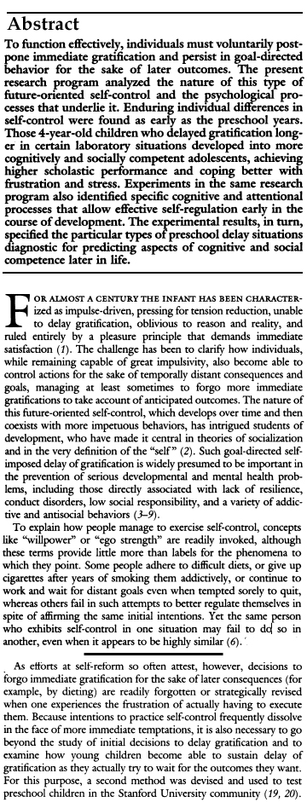

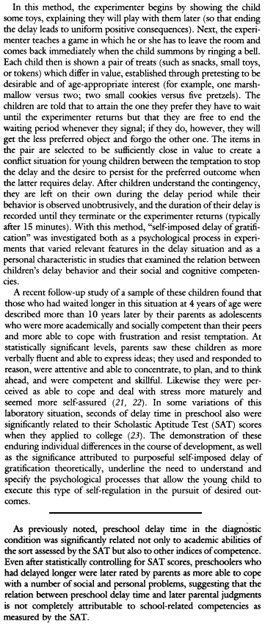

In your group, discuss the following question. After a few minutes, your instructor will ask each group to report out.

- Describe the differences between these two texts. How do you explain the differences? Which is better writing? Why?
- Who do you think the author of each article was writing for? What kind of a reader was he writing for?

Next we’d like each group to work on the following:
- “Translate” the first sentence in the scholarly article—“To function effectively, individuals must voluntarily postpone immediate gratification and persist in goal-directed behavior for the sake of later outcomes.”—into more ordinary language.
Finally, in your group, discuss the following question. After a few minutes, your instructor will ask each group to report out.

- Mischel finds a surprisingly strong relationship between the ability to delay gratification as a four-year-old and a number of positive outcomes later in life. Does this relationship surprise you? Why or why not?

Activity 3: More Marshmallows
For this activity, please begin by reading the following article.

This article appears on the University of Rochester website in a section titled “NewsCenter,” where articles about the accomplishments of University faculty are reported.

http://rochester.edu/news/show.php?id=4622

The Marshmallow Study Revisited

For the past four decades, the "marshmallow test" has served as a classic experimental measure of children's self-control: will a preschooler eat one of the fluffy white confections now or hold out for two later?
Now a new study demonstrates that being able to delay gratification is influenced as much by the environment as by innate ability. Children who experienced reliable interactions immediately before the marshmallow task waited on average four times longer—12 versus three minutes—than youngsters in similar but unreliable situations.
"Our results definitely temper the popular perception that marshmallow-like tasks are very powerful diagnostics for self-control capacity," says Celeste Kidd, a doctoral candidate in brain and cognitive sciences at the University of Rochester and lead author on the study to be published online October 11 in the journal Cognition.
"Being able to delay gratification—in this case to wait 15 difficult minutes to earn a second marshmallow—not only reflects a child's capacity for self-control, it also reflects their belief about the practicality of waiting," says Kidd. "Delaying gratification is only the rational choice if the child believes a second marshmallow is likely to be delivered after a reasonably short delay."
The findings provide an important reminder about the complexity of human behavior, adds coauthor Richard Aslin, the William R. Kenan Professor of brain and cognitive sciences at the University. "This study is an example of both nature and nurture playing a role," he says. "We know that to some extent, temperament is clearly inherited, because infants differ in their behaviors from birth. But this experiment provides robust evidence that young children's action are also based on rational decisions about their environment."
The research builds on a long series of marshmallow-related studies that began at Stanford University in the late 1960s. Walter Mischel and other researchers famously showed that individual differences in the ability to delay gratification on this simple task correlated strongly with success in later life. Longer wait times as a child were linked years later to higher SAT scores, less substance abuse, and parental reports of better social skills.
Because of the surprising correlation, the landmark marshmallow studies have been cited as evidence that qualities like self-control or emotional intelligence in general may be more important to navigating life successfully than more traditional measures of intelligence, such as IQ.
The Rochester team wanted to explore more closely why some preschoolers are able to resist the marshmallow while others succumb to licking, nibbling, and eventually swallowing the sugary treat. The researchers assigned 28 three- to five-year-olds to two contrasting environments: unreliable and reliable. The study results were so strong that a larger sample group was not required to ensure statistical accuracy and other factors, like the influence of hunger, were accounted for by randomly assigning participants to the two groups, according to the researchers. In both groups the children were given a create-your-own-cup kit and asked to decorate the blank paper that would be inserted in the cup.
In the unreliable condition, the children were provided a container of used crayons and told that if they could wait, the researcher would return shortly with a bigger and better set of new art supplies for their project. After two and a half minutes, the research returned with this explanation: "I'm sorry, but I made a mistake. We don't have any other art supplies after all. But why don't you use these instead?" She then helped to open the crayon container.
Next a quarter-inch sticker was placed on the table and the child was told that if he or she could wait, the researcher would return with a large selection of better stickers to use. After the same wait, the researcher again returned empty handed.
The reliable group experienced the same set up, but the researcher returned with the promised materials: first with a rotating tray full of art supplies and the next time with five to seven large, die-cut stickers.
The marshmallow task followed, with the explanation that the child could have "one marshmallow right now. Or – if you can wait for me to get more marshmallows from the other room – you can have two marshmallows to eat instead." The researcher removed the art supplies and placed a single marshmallow in a small desert dish four inches from the table's edge directly in front of the child. From an adjoining room, the researchers and the parent observed through a computer video camera until the first taste or 15 minutes had lapsed, whichever came first. All children then received three additional marshmallows.
"Watching their strategies for waiting was quite entertaining," says Holly Palmeri, coauthor and coordinator of the Rochester Baby Lab. Kids danced in their seats, sang, and took pretend naps. Several took a bite from the bottom of the marshmallow then placed it back in the desert cup so it looked untouched. A few then nibbled off the top, forgetting they could then no longer hide the evidence since both ends were eaten, she said.
"We had one little boy who grabbed the marshmallow immediately and we thought he was going to eat it," recalled Kidd. Instead he sat on it. "Instead of covering his eyes, he covered the marshmallow."
Children who experienced unreliable interactions with an experimenter waited for a mean time of three minutes and two seconds on the subsequent marshmallow task, while youngsters who experienced reliable interactions held out for 12 minutes and two seconds. Only one of the 14 children in the unreliable group waited the full 15 minutes, compared to nine children in the reliable condition.
"I was astounded that the effect was so large," says Aslin. "I thought that we might get a difference of maybe a minute or so… You don't see effects like this very often."
In prior research, children's wait time averaged between 6.08 and 5.71 minutes, the authors report. By comparison, manipulating the environment doubled wait times in the reliable condition and halved the time in the unreliable scenario. Previous studies that explored the effect of teaching children waiting strategies showed smaller effects, the authors report. Hiding the treat from view boosted wait times by 3.75 minutes, while encouraging children to think about the larger reward added 2.53 minutes.
The robust effect of manipulating the environment, conclude the authors, provides strong evidence that children's wait times reflect rational decision making about the probability of reward. The results are consistent with other research showing that children are sensitive to uncertainly in future rewards and with population studies showing children with absent fathers prefer more immediate rewards over larger but delayed ones.
The findings, says Kidd, are reassuring. She recalls reading about the predictive power of these earlier experiments years ago and finding it "depressing." At the time she was volunteering at a homeless shelter for families in Santa Ana, California. "There were lots of kids staying there with their families. Everyone shared one big area, so keeping personal possessions safe was difficult," she says. "When one child got a toy or treat, there was a real risk of a bigger, faster kid taking it away. I read about these studies and I thought, 'All of these kids would eat the marshmallow right away.' "
But as she observed the children week after week, she began to question the task as a marker of innate ability alone. "If you are used to getting things taken away from you, not waiting is the rational choice. Then it occurred to me that the marshmallow task might be correlated with something else that the child already knows—like having a stable environment."
So does that mean that if little ones gobble up desert without waiting, as is typical of preschoolers, parents should worry that they have failed to be role models of reliability every minute?
Not necessarily, say the researchers. "Children do monitor the behavior of parents and adults, but it is unlikely that they are keeping detailed records of every single action," says Aslin. "It's the overall sense of a parent's reliability or unreliability that's going to get through, not every single action."
Adds Kidd: "Don't do the marshmallow test on your kitchen table and conclude something about your child. It especially would not work with a parent, because your child has all sorts of strong expectations about what a person who loves them very much is likely to do."

Your instructor will break the class into groups. In your groups discuss the following question. Be ready to report out after a few minutes.

Does the article about the University of Rochester study change what you think about delayed gratification? Discuss any changes and the reason for them. Now what do you think about delayed gratification as a strategy in your own life?

Activity 4: Short Writing 2: Experiencing Delayed Gratification

Think about a time when you had an experience with delaying gratification, a time when you had to choose between doing something enjoyable right away or doing something less enjoyable but with benefits in the future.

Write a one-page paper about this experience to be read by the students in the class. Here are some questions you may want to think about.

What made the short term choice so tempting? What would be so enjoyable about it? What were the benefits of choosing the less enjoyable option?

If you chose the short-term enjoyable option, how did that work out? Was it a mistake? Was it as enjoyable as you expected? Did it cost you anything in the longer term?

If you chose the less enjoyable but more beneficial in the long term option, why did you make this decision? How did you convince yourself to give up the more enjoyable option? Did you really benefit in the long term?

If you prefer, you can write about someone else who faced such a choice, not you yourself.

Remember that your paper may be shared with the entire class.

Activity 5: Discussion of Short Writing 2: Experiencing Delayed Gratification

Your instructor will divide the class into groups of three or four. Take about ten minutes to read all the papers from your group. Then designate each member of the group as note taker for one of the questions. Then, for about a half hour, discuss the following questions.

- What kinds of strategies seem to work best when people want to delay gratification?
- What kinds of strategies don’t seem to work when people want to delay gratification?
- Are there times when delaying gratification may not be the best strategy?
- Sometimes is it possible to find a middle ground between delaying gratification and instant gratification?

After a half hour, take about 10 minutes for the note takers to summarize what the group said about each question. Your instructor will collect these summaries, combine them into one document, and give everyone a copy at the next class.

Activity 6: Essay 1 (Delayed Gratification)

For this assignment, I’d like you to write a three to four page essay that grows out of your reading, your discussion, and your thinking about delayed gratification. Your audience for this paper is students who will be arriving at your institution next year. Your essay, if accepted by the college’s New Student Orientation Committee, will be included in a packet of information new students will receive to help them understand how to be more successful in college.

Think deeply about delayed gratification—what it is, when it is a good strategy, how might one be successful at doing it. Support your argument with information from the articles you have read or others you locate yourself and/or with examples from your own life or from the lives of people you know.

Before you do any actual writing on this assignment, your instructor will form the class into groups of four or so. In your group, discuss who the audience will be for this writing. What do you know about them? Is there only one audience for your writing? If you think there is more than one, what do you know about the second audience? Who might they be?

