Universal design (close relation to inclusive design) refers to broad-spectrum ideas meant to produce buildings, products and environments that are inherently accessible to older people, people without disabilities, and people with disabilities.

Universal Design has been built in to US national initiatives for nearly two decades
Universal Design for Learning is referred to by name in American legislation, such as the Higher Education Opportunity Act (HEOA) of 2008 (Public Law 110-315), ^{[6]} the 2004 reauthorization of the Individuals with Disabilities Education Act (IDEA), and the Assistive Technology Act of 1998. The emphasis being placed on equal access to curriculum by all students and the accountability required by IDEA 2004 and No Child Left Behind legislation has presented a need for a practice that will accommodate all learners.^{[7]}
Universal Design for Learning (UDL) is an educational framework based on research in the learning sciences, including cognitive neuroscience, that guides the development of flexible learning environments that can accommodate individual learning differences.^{[1]}
- Multiple means of representation to give learners various ways of acquiring information and knowledge,
- Multiple means of expression to provide learners alternatives for demonstrating what they know, and
- Multiple means of engagement to tap into learners' interests, challenge them appropriately, and motivate them to learn.^{[3][4]}
Curriculum, as defined in the UDL literature, has four parts: instructional goals, methods, materials, and assessments.^{[5]} UDL is intended to increase access to learning by reducing physical, cognitive, intellectual, an organizational barriers to learning, as well as other obstacles. UDL principles also lend themselves to implementing inclusionary practices in the classroom.

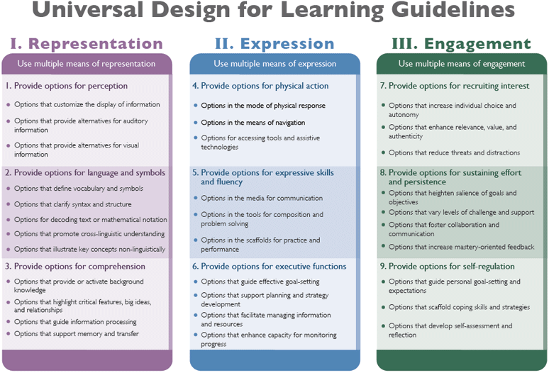

Reflection
What (Course Design)  Deliberate attention to equitable access in curriculum and delivery | How  Universal Design  Give one/Get one  Think, Pair, Share  Paired Discussions (Speed Dating)  Perspectives Activity | Why  To promote student success, especially among under-served populations
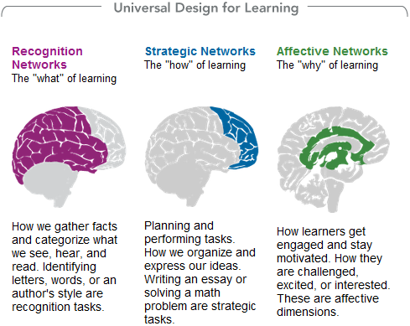

Some Principles of Active Learning as Universal Design

- Students do more talking than I do
- Students talk more to each other than to me
- Students encounter not only diverse opinions and ideas, but the diverse people expressing them
- Emphasize students’ participation in a learning community (Contact Zone)
- Defuse stereotype threat and growth mindset
- Cultivate a Growth Mindset
- Explicitly emphasize metacognition

1.
Stereotypes cause people to perform poorly even in the absence of outright prejudice or discrimination
“Stereotype threat is defined as a situational predicament in which individuals are at risk of confirming negative stereotypes about their group. It is the resulting sense that one might be judged in terms of negative stereotypes about one's group instead of on personal merit.”

Stereotype threat is unconscious and causes measurable physiological reactions
“So we can say now that part of stereotype threat’s effect – its impairment of women’s math performance, of lower-class French students’ performance on language exams, of white males’ miniature golf performance, and so on – is caused directly by its effect of increasing heart rate, blood pressure, and related physiological signs of anxiety to the point that these reactions interfere with performance. We can also say that people aren’t much aware that this is happening. They don’t report it when asked. It’s a cost we don’t seem to recognize we’re paying. But is it the only way identity threat interferes with performance? Wouldn’t it directly affect our thinking as well?...the answer is yes.”
Steele, Claude. Whistling Vivaldi, Boston: Norton 2011. Print

2.
- Cultivating openness to diversity and challenge (ODC) promotes student success and retention (Bowman 2014)

ODC is also positively and directly related to first-year college GPA and first-to-second year retention (although the effect for retention is marginally significant by the conservative criterion used in this study). In other words, this form of openness directly predicts student success. Experiencing diversity and challenge plays an integral role in student growth (e.g., Evans, Forney, DiBrito, Patton, & Renn, 2010; Pascarella & Terenzini, 2005), and research has demonstrated that the several experiential “outcomes” examined in this study are associated with greater academic achievement and retention (for reviews, see Kuh, Kinzie, Buckley, Bridges, & Hayek, 2006; Robbins et al., 2004).

- Like “grit,” “growth mindset,” and other non-cognitive attributes, ODC improves student success and retention (Bowman 2014)

ODC is positively associated with several broad indices of student engagement, first-year college GPA, and first-to-second year retention. Simply stated, students who are open to diversity and challenge are more likely to seek out new experiences and to achieve educational success.
Recent discussions have focused on the use of non-cognitive attributes (Sedlacek, 2004) or dimensions of character (Tough, 2012) to predict and ultimately improve academic performance and persistence. ODC can be viewed as one such desirable attribute that also merits attention.

Bowman, N. A. (2013). How Much Diversity is Enough? The Curvilinear Relationship Between College Diversity
Interactions and First-Year Student Outcomes. Research In Higher Education, 54(8), 874-894.
doi:10.1007/s11162-013-9300-0

3.

The Contact Zone and Teaching
Pratt applies the notion of the contact zone to dealing with difference and conflict in the classroom. She notes that this type of teaching is challenging, but rewarding. She writes, “All the students in the class had the experience ... of having their cultures discussed and objectified in ways that horrified them; all the students experienced face-to-face the ignorance and incomprehension, and occasionally the hostility of others ... Along with rage, incomprehension, and pain, there were exhilarating moments of wonder and revelation, mutual understanding, and new wisdom—the joys of the contact zone"(39).^{[1]}
In addition to the importance of engaging student in difficult conversations, Pratt also notes the importance of “safehouses,” which are “social and intellectual spaces where groups can constitute themselves as horizontal, homogenous, sovereign communities with high degrees of trust, shared understandings, temporary protection from legacies of oppression” (40).^{[1]}

In a 1991 keynote address to the Modern Language Association titled “Arts of the Contact Zone,” Mary Louise Pratt introduced the concept of “the contact zone.” She articulated, “I use this term to refer to social spaces where cultures, meet, clash and grapple with each other, often in contexts of highly asymmetrical relations of power, such as colonialism, slavery, or their aftermaths as they lived out in many parts of the world today” (34).^{[1]} Pratt described a site for linguistic and cultural encounters, wherein power is negotiated and struggle occurs.

4.
From the literature about Metacognition

Metacognition is, put simply, thinking about one’s thinking. More precisely, it refers to the processes used to plan, monitor, and assess one’s understanding and performance. Metacognition includes a critical awareness of a) one’s thinking and learning and b) oneself as a thinker and learner.

Initially studied for its development in young children (Baker & Brown, 1984; Flavell, 1985), researchers soon began to look at how experts display metacognitive thinking and how, then, these thought processes can be taught to novices to improve their learning (Hatano & Inagaki, 1986). In How People Learn, the National Academy of Sciences’ synthesis of decades of research on the science of learning, one of the three key findings of this work is the effectiveness of a “‘metacognitive’ approach to instruction” (Bransford, Brown, & Cocking, 2000, p. 18).

Metacognitive practices increase students’ abilities to transfer or adapt their learning to new contexts and tasks (Bransford, Brown, & Cocking, p. 12; Palincsar & Brown, 1984; Scardamalia et al., 1984; Schoenfeld, 1983, 1985, 1991). They do this by gaining a level of awareness above the subject matter: they also think about the tasks and contexts of different learning situations and themselves as learners in these different contexts. When Pintrich (2002) asserts that “Students who know about the different kinds of strategies for learning, thinking, and problem solving will be more likely to use them” (p. 222), notice the students must “know about” these strategies, not just practice them. As Zohar and David (2009) explain, there must be a “conscious meta-strategic level of H[igher] O[rder] T[hinking]” (p. 179).

5.

- Students can learn anti-stereotype threat “growth mindsets” in the classroom
“Research shows that professors can reduce stereotype threat in their classrooms and change students’ mindsets from fixed to growth through the messages they send their students. Educate professors about stereotype threat, the benefits of a growth mindset, and how to create a growth-mindset environment in their classrooms by sending students the message that intellectual skills can be acquired and anyone who works hard can succeed.”
Hill, Catherine. Why So Few? Women in STEM, American Association of University Women, 2011.

- Defusing stereotype threats will fix America’s minority achievement gap
“A preponderance of evidence strongly suggests that underperformance, when not caused by discrimination against a group in grades, is likely caused by stereotype and identity threats and the interfering reactions they cause. It also suggests that tests used to measure students’ potential for some subsequent level of schooling, under a common set of testing conditions, can underestimate the actual potential of stereotyped students. This effect has been difficult to discern because the subsequent grade performance of these students is also depressed by stereotype threat, this time in the schooling environment itself. That these threats cause something as lawfully observed in American society as minority student underperformance means that they are as common as crabgrass, and just about as unruly.”
Steele, Claude. Whistling Vivaldi, Boston: Norton 2011. Print

