- Get into groups of 4-5.
- Each group will receive a poster board and an envelope.
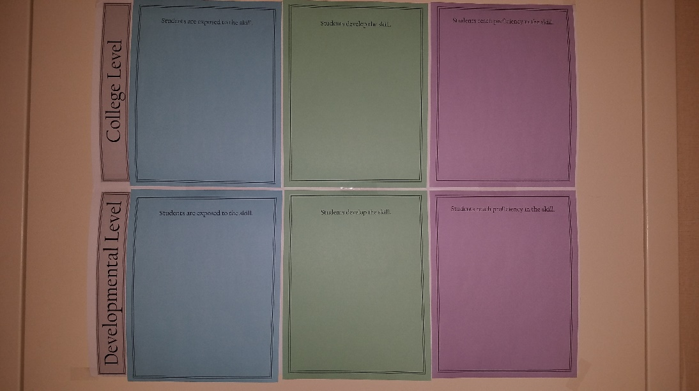
- On the poster board, you will see a row for developmental English and a row for college-level English. For the purpose of this exercise, consider a developmental course as required for students with an ACT of 18 or below, and college-level for students with an ACT of 19 or above, regardless of whether they are in a co-requisite or straight 1000-level class.
- The columns on the poster board represent a spectrum of the degree to which students would practice skills in an English course: exposure, development, and proficiency.
- Each envelope contains sets of colored paper that list specific skills you’d expect to see taught in English courses. There are two identical sets for each color so that you could place the skill as appropriate for both developmental and college-level courses.
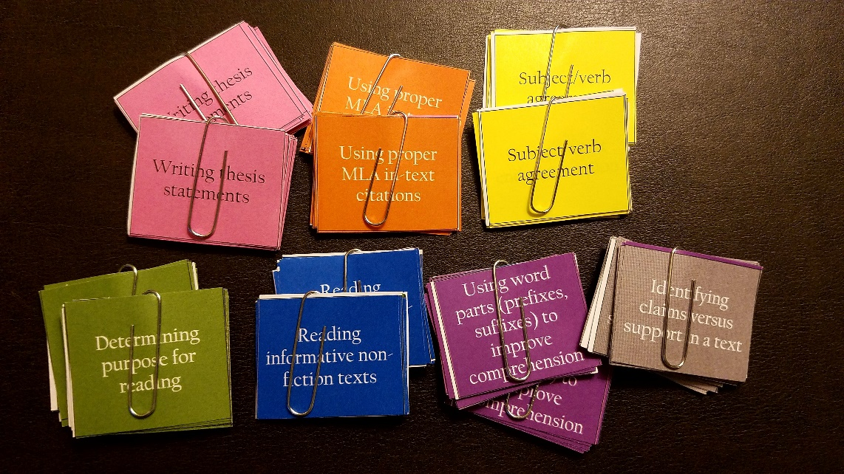
- There are also blank pieces so that if we overlooked anything important, you can write it in for yourselves.
- As a group, look through the skills and negotiate together where you think the skills belong (at the developmental or college level) and whether students should merely be exposed to it, spend time developing it, or reach full proficiency in it by the end of the course.
- You don’t have to get through each skill in your envelope. It’s more important to experience the process of discussing and negotiating than to make a complete chart.

