Addressing Non-Cognitive Issues

It is now well established that the success rate for students placed in developmental education is far too low. At the Community College of Baltimore County, we found only about 33% of students placed in our upper level developmental course ever passed the credit-level composition course. The Community College Research Center, based on a study of 256,672 first-time, credential-seeking students at fifty-seven Achieving the Dream colleges, reports similar results:

Results of the study indicate that fewer than one half of the students who are referred to remediation actually complete the entire sequence to which they are referred. About 30 percent of students referred to developmental education do not enroll in any remedial course, and only about 60 percent of referred students actually enroll in the remedial course to which they were referred. The results also show that more students exit their developmental sequences because they did not enroll in the first or a subsequent course than because they failed or withdrew from a course in which they were enrolled.

After surveying our students at CCBC for five consecutive semesters, we are convinced that most students who do not succeed do not for one or both of these reasons:

- Life problems become overwhelming.
- Affective issues—mostly centered around fear, anxiety, and a suspicion that they are not “college material”—cause them to give up.

Very few writing faculty have any preparation for addressing these non-cognitive issues. And yet, we have found that there are things we can do to reduce the chances that students will give up because of thee non-cognitive factors. In this document we will discuss strategies that have worked for us.

But first a few cautionary words. Even though we are encouraging faculty to engage with students over these non-cognitive issues, we also recognize that few faculty have any formal preparation in these areas. Consequently, it is important that we not take on the formal role of financial counselor, legal advisor, marriage counselor, or medical consultant. Rather, we suggest that faculty think of themselves in a less formal role. Imagine that a nephew or niece or even a next door neighbor came to you for advice. You wouldn’t say, “I’m sorry, but I am not a lawyer or a marriage counselor. I cannot help you.” What most of us would do is listen carefully and offer any insights we do have in an informal role and, if it seemed appropriate, offer a suggestion of an expert who might be appropriate. This is closer to the role we are suggesting for responding to students with non-cognitive issues.

Another issue that faculty must sometimes wrestle with is how much compassion is appropriate. Because we care about our students and are understanding of the stresses in their lives, we sometimes cut them some slack. We give extensions on due dates and allow them to make up work they have missed. The difficulty is determining whether this compassion is, in fact, encouraging behaviors that will be problematic in the long run. Making the right choice between compassion and “tough love” is not always easy, and few of us will always get it right.
Students persist productively
1. Students believe they can succeed.

Faculty discuss the concepts of fixed and growth mindsets. Stanford psychologist Carol Dweck has pointed out that there are two ways to think about our abilities. Those with a “fixed mindset” think that their ability is set from an early age: “I’ve never been good at writing” or “I’m just not athletic.” Those with a “growth mindset” believe that they can improve their abilities if they work at it.

As Dweck explains, “the belief that intelligence is fixed dampened students' motivation to learn, made them afraid of effort, and made them want to quit after a setback. This is why so many bright students stop working when school becomes hard. Many bright students find grade school easy and coast to succeed early on. But later, when they are challenged, they struggle. They don't want to make mistakes and feel dumb — and, most of all, they don't want to work hard and feel dumb. So they simply retire.”

A video of Carol Dweck discussing the concept of mindsets is available at the following url. It’s only eight minutes long:

https://www.youtube.com/watch?v=ICILzbB1Obg

You might want to have your students watch it and then get in groups to answer a question about it or to play the “doubting and believing” game.

Faculty praise effort rather than ability. When talking to students about their work, we encourage a “growth mindset” One way to encourage a growth mindset is to avoid saying to students, “This is a very good essay; you’re a good writer.” Instead, we might say, “This is a very good essay; you must have worked hard on it.” Praising effort rather than ability will encourage students to adopt the attitude that success results from effort, not their innate ability. It is also important to point out that effort doesn’t always result in success, that just because a student works hard doesn’t always mean they will receive a high grade.

2. Students make sufficient effort.

Faculty create incentives to encourage student effort. One way to do this is to create a system in which points are given for meeting the requirements of the course. Points are given for attending class, for completing work by deadlines, for participation, and for the quality of papers written. In a world in which students feel pressure from every sector of their lives—from their jobs, their family responsibilities, and from many other sources—if we do not create rewards for the work we know they need to do, it is likely they will do the work that is rewarded in the rest of their lives.

Some faculty create challenges for the class. “If everyone turns in the next paper on time, I’ll bring in cookies for the class.” Some faculty create groups that compete for a reward. The group that has best attendance for the month gets the cookies.

Faculty assist students to work well in groups. By asking students to work on tasks in groups of three to five, faculty provide an opportunity to students to play a role in encouraging each other to make sufficient effort. If a group is having the “slacker” problem—one or two members of the group are not doing their share of the work—faculty can intervene to discuss how the group might deal with the problem. In classes making use of a point system as discussed above, faculty can award each group a number of points and ask them to allocate those points among the group members according to their effort.

Faculty can create classroom activities designed to motivate students to make greater effort. Discussions of how much time it takes to complete assignments may help some students to become aware that the amount of time they have been devoting to assignments is not adequate. Videotapes of students who have been successful—perhaps recent graduates—discussing how much effort they made can help. Even discussions of the socio-economic forces that have worked against their success to date can help students realize how much effort they need to make to avoid being victims of those forces.

Students can be motivated to work hard when they understand the concept of not letting themselves become victims. Early in the semester, developmental students can be asked to write a short paper explaining why they find themselves placed in a developmental writing course. The following are typical answers extracted from a sample of these papers:

- I rushed through the test.
- I had a hard time paying attention.
- I didn’t work very hard in high school
- I didn’t like all the reading
- I didn’t know some words
- I had somewhere to go.
- I was tired.
- I was bored.
- I took all three tests in a half hour.
- I've been out of school a long time
- I didn't take high school seriously
- I'm a horrible writer.

I posted these theses statements on a slide and asked students what they notice about these various explanations. Fairly shortly someone always points out that all of them us the pronouns I as the subject. In other words, they seem to think it’s their own fault they are in a developmental writing course.

Next I show the class the following chart:

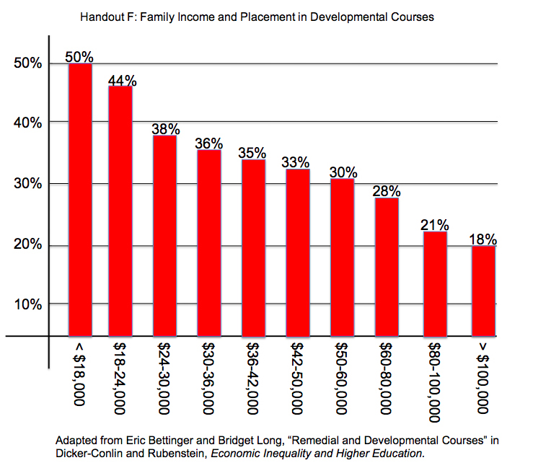

I ask students what this chart shows. Fairly soon they realize that it shows that there is a direct relationship between family income and the chances a student will end up in developmental courses. I ask them to explain why this might be so. I ask if they’ve experienced anything in their lives that would make it more likely they would end up in a developmental writing class. They report factors like the following:

- My high school was terrible.
- I was sick a lot during high school.
- My parents are not educated.
- I lived in six foster homes when I was growing up.
- Classes in my high school had more than 50 students.
- My parents and friends used terrible grammar.
- We were homeless, so it was hard to study.
- My mother never wanted me to go to college.
- I was never asked to write in high school.

These are quite different from the earlier list, so I ask them which are true. They usually reply that all of them are. And then I ask the crucial question: of all these explanations, which do they have any control over? Of course, they have no control over the second set, but they do have control over the first set. In other words, and this is the key point, there are societal forces that make it more likely students from lower socio-economic classes will end up in developmental courses. In order to overcome these forces, in order to avoid being victimized by them, they will need to work even harder than students who grew up in wealthier families.

Faculty help students adopt delayed gratification as a strategy. Students may be better able to persist, if they are aware of the strategy of delayed gratification—giving up some short-term benefit in order to gain a much greater long-term benefit. It may be a good idea to discuss the study conducted by Walter Mischel at Columbia University in 1996. Four-year-old children were seated at a desk where there were a marshmallow and a bell. The researcher left the room after explaining to the child that they had two options: they could ring the bell, in which case the researcher would return to the room, and the child could eat the marshmallow. Or, the child could wait until the researcher returned on her own, in which case the child would get to eat two marshmallows. Mischel followed the children for more than ten years and found that those who were able to defer gratification were significantly more successfully academically than those who rang the bell. Asking students to discuss times when they have faced similar choices seems to help them understand the advantages of being able to delay gratification. A video demonstrating this marshmallow study in available at this url:

http://www.youtube.com/watch?v=Yo4WF3cSd9Q

3. Students avoid non-productive effort.

Understanding non-productive effort. Most of us faculty are aware that students who put in more effort are more likely to succeed, but sometimes we are not as aware of the importance of avoiding non-productive effort. Imagine a student who is trying to get to the other side of a brick wall. He runs as hard as he can and throws himself at the wall. The wall is still standing, and he has a bloody nose. Now picture him picking himself up, backing up, and running at the wall again . . . and again. That student is an extreme example of what we mean by non-productive effort. He is trying very hard to knock that wall down, but is making absolutely no progress.

Now imagine the same student taking a long walk along the wall and discovering an unlocked gate. Now he is make productive effort which allows him to reach the other side of the wall.

It is important that we motivate our student to make an effort, but we also need to make sure that the effort they make will be productive.

Guided reflection on performance. Spend some time asking students to describe how they went about writing a paper. Help students understand the difference between non-productive and productive effort when writing. You might place students in groups and ask each group to come up with one example of when one of them exerted effort that was non-productive and one example of productive effort.

Faculty ask students to think about how they're thinking as they write a paper so they recognize nonproductive effort when it happens. Some faculty ask students to keep process logs, journals, or blogs or to write reflective essays after they’ve completed a draft so they examine the thinking behind their writing. One of my favorites is to ask students to write about how they arrived at their thesis for a paper

Faculty lead discussions explicitly talking about strategies used to write papers or research or read. Successful strategies are important to identify, but so are strategies that are not successful.

4. Students learn to learn from setbacks.

Faculty discuss with students the two orientations toward setbacks. Martin Seligman has argued that there are two orientations to misfortune: the pessimistic person feels that a failure is personal, permanent, and pervasive. “It’s all my fault, it’s always going to be like this, and it’s going to undermine every aspect of my life.” The optimistic student, who is able to learn from setbacks, feels that it is neither personal nor permanent nor pervasive. I would add that, of course, there is room for responses in the gray area—responses that recognize that I have some responsibility without taking on all the responsibility.

Faculty assure students who perform unsuccessfully that while the standards are high, they can succeed. Rebecca Cox’s The College Fear Factor is helpful here. It is important that students know that we are asking them to complete challenging tasks and that we believe they can be successful at these tasks.

Ask students to apply Dweck’s ideas about mindsets to the experience of setbacks. This is a great opportunity to apply an earlier concept to a new topic. Dweck discusses mindsets and attitudes toward setbacks on pages 1 to 9 on her book Mindset.

5. Students have short- and long-term goals.

What’s Important Inventory. Organize the class into groups of three or four. Ask each group to brainstorm a list of what is important for them about a career they might want to pursue. After thirty minutes or so, have the groups report out by writing their lists on the blackboard or projecting them on a screen. Ask the class to read over the lists and answer the following questions:

- What issues did most groups include?
- What were the most interesting issues that were listed by only one group?
- What issues can you think of now that weren’t included on any lists?

After class, you can combine all the lists into one consolidated list for the class. Below is a list consolidated from several semesters of my students doing this activity. You may want to share any from the list that weren’t on your students’ lists to insure they’ve considered as many issues as possible:

- What kind of income should I expect from this career?
- Are there jobs in this field?
- What is the long-term prospect for jobs in this career?
- How much education would I need to be successful in this career?
- Do I have abilities that would be important to succeeding in this career?
- Would I enjoy the kinds of work this career requires?
- How much travel does this career require?
- How stressful is this kind of career?
- Would working in this field require compromise with any of my values?
- If I spent my life working in this career, would I feel I had made a contribution to society?
- Would people be impressed if I told them I worked in this career?
- Would my parents be proud of me?

Faculty ask students to list goals for the next five, for the next year, and years for the next month. Then ask them to write a letter to themselves five years in the future about these goals. Some faculty actually mail these letters to students after a couple of years.

6. Students believe that what they are learning has value.

Belief in the value of the work. Students are more likely to persevere if they believe the work will be valuable to them at some point. Delayed gratification, for example, works only when you believe that delaying will, in fact, result in two marshmallows.

Faculty make sure students understand the socio-economic benefits of educational credentials. Faculty might present data showing the difference in incomes, unemployment rates, or chances of being laid off as a function of credentials earned. See for example, the following chart.

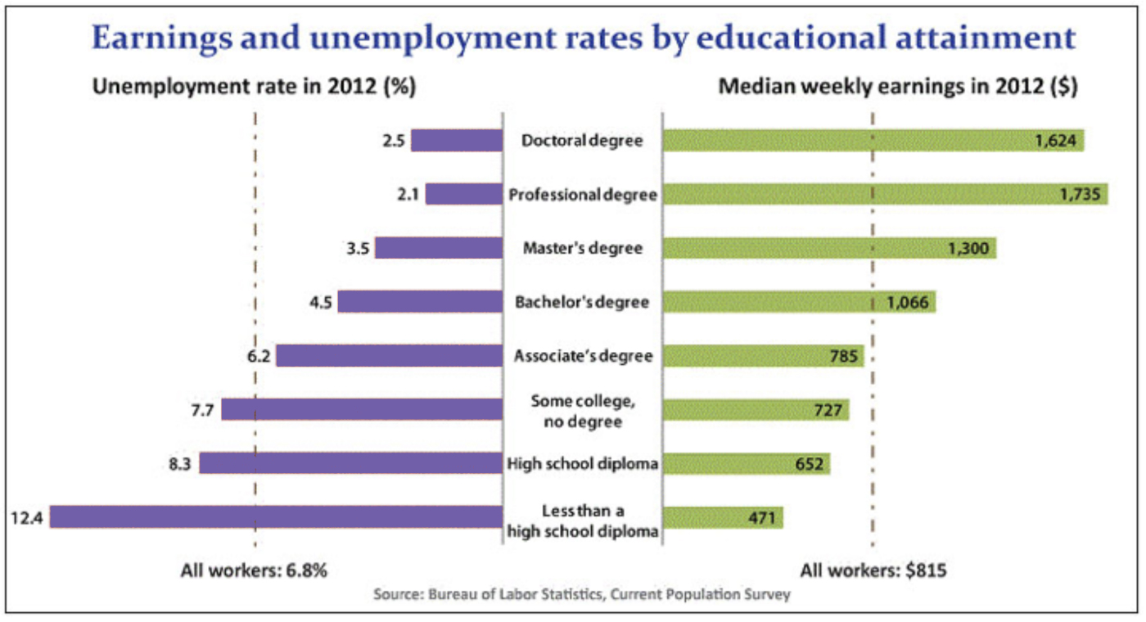
Table 1: Source: Bureau of Labor Statistics, Current Population Survey, May 22, 2013.

Faculty discuss the shorter-term benefits of what students are learning. Faculty might discuss how important the skills being learned—in this case writing—to success in college courses and in most careers. Or, students might be asked to interview professors in their field about writing requirements in their courses.

Faculty discuss the less tangible benefits of a college education. Faculty might ask students working in groups to generate a list of the non-job-related benefits of a college education. Alternatively, they could ask students to write about these.

7. Students attend class regularly, complete assigned readings, and turn in written assignments on time.

Students master college behavior
Faculty make their standards clear. In the syllabus, in handouts and assignments, and in class discussions, it is important that faculty are clear about their standards—what is expected on each assignment.

Faculty encourage students to help each other. One way to do this is to make use of “home groups” in the class. These small groups meet together regularly in class, work on long-term projects together, and are encouraged to support each other outside of class.

Faculty provide incentives to encourage successful college behavior. As discussed above (#2), faculty find ways—perhaps a point system—to incentivize successful college behavior.

Faculty discuss Rebecca Cox’s theory about why some students engage in behavior that seems to undermine their chances of succeeding. It’s also a good idea for faculty to be aware that much of the student behavior that puzzles us—students who leave placement tests after fifteen minutes, students who don’t show up for exams, students who turn in papers that appear to have been written with no more than fifteen minutes of effort—much of this behavior is defensive. By not trying, students make sure that their resulting failures do not reflect their abilities. “If I didn’t try, then no one can say that the test proves anything about me.”

By asking students to read an excerpt from The College Fear Factor and to write about it, faculty help students to understand that fear of failing can lead to behavior that almost guarantees failure.

It is important to recognize that many developmental student are deeply afraid that they are not smart enough for college. Many of them have had experience in the educational system that have caused them to have doubts about their intelligence, or more specifically, about their ability to write. For many students, the first few weeks of the semester are the crucial period for increasing or reducing their fears. Anything faculty can do, early in the semester to provide students with a positive, a confidence-building experience in those early weeks may well prevent a couple of those “early disappearances,” that we’ve all experienced.

Early alert. It is crucial that faculty act quickly when students start to “go off the tracks.” Once a student misses three of four classes in a row or falls two or three assignments behind, it is often impossible for them to catch up.

Scheduling App. Have students download a scheduling app like EasyScheduler (free). Show them how to enter the due dates for upcoming assignments, but also have them schedule the time when they will work on each assignment.

8. Students join the conversation.

Faculty make use of active learning. Frequently, forming groups of three to five students to work on intellectually challenging tasks like summarizing a reading, determining why something is the way it is, or revising a piece of writing makes it more likely that all students will become part of the conversation.

Faculty make use of on-line resources. Asking students to contribute to on-line discussions—chat rooms, discussion boards, and blogs—gives them practice at joining the conversation. Ideally students will come to see that even their formal papers are part of an ongoing intellectual discussion.

Faculty have students "publish" their writing in various ways. Blogs (public or class wide), through pdfs, or on websites.

Faculty ask students to comment on each other's writing, through discussion boards. Students can also be asked to quote and cite each other in papers to give them a sense of being in dialogue with each other.
9. Students seek help when appropriate.

Faculty take steps to reduce students’ fear of them. Early in the semester, faculty are especially attentive to the need to establish a supportive, friendly atmosphere.

Faculty encourage students to feel comfortable talking to them. can help students get over their fear of talking with us by a deliberate effort to engage each student in a one-on-one conversation, preferably in the faculty member’s office. It’s important that this conversation be informal and as non-threatening as possible. Having experienced a conversation with the faculty member once, the hope is that students will feel comfortable doing so again. The faculty member might ask a reticent student to help carry some materials back to his office, or noticing that a student is headed to the library, the faculty member might walk along too and begin a conversation.

Faculty are given rosters of consultants willing to work with students on life issues. Usually developed by departments or programs, these rosters include names, emails, and phone numbers of experts on campus who are willing to work with students or even to visit classes. Simply telling a student to go see someone in a certain office is unlikely to have a positive result. When possible faculty can walk the student to the consultants office, but usually that is not possible. In these cases, if the faculty member calls the consultants and sets up an appointment, it is much more likely that the student will actual visit the consultant.

Making sure students seek help. The least effective way to accomplish this is simply to give the student an office location and tell them to go there for help. Too often, they don’t go. Sometimes, either because the situation seems dire or because the student seems reticent or because the faculty member feels generous, the faculty member may even walk the student to the office in question and introduce the student to the person they need to talk with. Most of us, most of the time, simply don’t have time to do this.

We have found an effective middle ground to be to make a phone call to the advisor or financial aid officer or department head and ask if they can talk with the student. This approach is most effective when we make the phone call on our cell right in front of the student. Now that the student knows that you have gone to some trouble for them, they are much more likely to actually show up for the appointment.

Faculty conduct classroom or out-of-class activities to encourage students to become familiar with college resources. Faculty can use scavenger hunts, quizzes, walking tours, and research projects that require students to explore the college’s resources.

Faculty ask students to write about asking for help. Faculty can ask students to write about a time when they needed help and asked for help and another time when they needed help but didn’t ask. Working in groups students can tease out the similarities and differences between when they were able to ask for help and when they were not.

10. Students learn the culture of the college community

Social Capital. Students who are the first generation in their families to attend college are often lacking in resources that are referred to as social capital. They may also be missing financial capital, but social capital can be just as crucial to success. These students frequently do not have anyone to turn to for advice, support, and encouragement when they encounter obstacles in college. If no one in their family has attended college, who can explain the many concepts and procedures that are so important to navigating the college system? Who can explain what office hours are for or what the FAFSA is or the difference between a degree and a certificate? In addition, it may be that no one they know has the kinds of connections that can put them in contact with someone who can advise them.

For us as basic writing teachers, this means we need to be much more careful in our explanations. We need to be alert to possible confusion about misunderstandings of policy or expectations. We need to be prepared to put students in contact with people at the college who can give them advice.

Because many assignments ask students to do something using terminology that students are not familiar with, an exercise built around the following list can help students better understand what their assignments are asking them to do.

argue
classify
compare
construct
contrast
create
criticize
define
defend
demonstrate
describe
design
develop
discuss
distinguish
evaluate
explain
identify
interpret
list
paraphrase
recall
repeat
schedule
solve
state
support
write

Students could work in groups with each group asked to write an explanation of a small number of these terms. Groups might then exchange lists and ask questions of each other. The final revised product could be handed out to all students.

A similar activity could be organized around a list of college terms like the following:

AA degree
appeal
accommodation
books on reserve
bursar
certificate
dean
department
essay
FAFSA
GPA
incomplete
major
office hours
paper
plagiarism
pre-requisite
probation
program
registration
school
syllabus
transfer
tutoring
WebCT
withdrawal
writing center

Guidebook to Campus Resources. Have the class develop a guide to campus resources. Students should do the research—visit offices, get office number, hours, phone numbers, and services available. They then decide on the format for the guidebook and assemble it. A great writing activity because they are writing for a real audience, but it also helps them become more familiar with the campus.
Students feel they belong in college.

The structure of ALP. The very structure of the ALP class will help tremendously with student attachment. Students in ALP are not excluded from credit courses; they are in first-year composition; they are in college and doing college-level work. They are not segregated away from stronger students; instead, they are in a class where half the students are college-level. What happens in an ALP developmental class feels like college, including the reading of college-level texts and the writing of college-level essays. When students successfully engage in these college-level tasks, they experience satisfaction many of them have never experienced before. The small class size and the frequent use of group activities encourages bonding among the students.

Active learning. Perhaps the quality that will keep students coming to class most reliably is engagement. Once students experience the pleasure of joining the conversation, the satisfaction that comes from solving an intellectual problem or understanding a new idea, they will be more likely to continue coming to class and engaging in the learning. Too many of our students have adopted the attitude, or perhaps the pose, of indifference. Sitting in the back of the room, these students stare out the window and seldom contribute to the conversation, even when called on.

How to overcome this resistance is not easy, but we must try. The strategies that show the most promise in this area are those known as active learning. It’s a lot easier to remain “tuned out” during a lecture than it is when you are in a small group that is wrestling with a difficult passage in a text.

11. Students identify as a college students.
s.

Organize the syllabus using backward curriculum design. If students, already unsure whether they really belong in college, find themselves in a classroom that feels like the sixth grade, their apprehension, their sense of stigmatization will only increase. This is one of the reasons we advocate for a curriculum in which students do college-level tasks, read college level texts, and write college-level essay . . . with lots of support and scaffolding.

Try to teach in a physical space that feels like a college classroom. Because ALP classes are small, we often schedule our meetings in smaller rooms where we sit around a conference table, an arrangement we call a seminar room.

Avoid asking students to perform activities that feel like 6th grade. Even though developmental students may be lacking some skills that were taught in the 6th grade, to repeat drills and exercises that are typical of 6th grade will exacerbate students’ feeling that they may not belong in college. This is why we strongly recommend against turning the class or even the first weeks of the class into a grammar review.

12. Students develop bonds with others at college.

Student bonding. A second strategy for encouraging engagement is to provide opportunities for students to get to know each other, perhaps even to form friendships. Early in the semester, we like to have students interview each other and then either write short biographies or introduce each other to the class as a whole. We encourage students to exchange phone numbers and/or email addresses. We frequently ask them to work together in small groups on a writing or reading task.

Study groups. Faculty encourage students to form study groups that meet regularly to study together.

13. Students experience the satisfaction of successful intellectual activities.

Faculty organize various celebrations of student writing. Sometimes portfolios of a semester’s work can be assembled to demonstrate students’ accomplishments. Other faculty hold TED events at which students present their own TED talks.

Students successfully cope with life problems

15. Students avoid being derailed by life issues.

Creating a safe atmosphere. There is no sure formula for doing this, but ALP faculty should seek out ways to create an atmosphere in the classroom that encourages students to feel it’s okay to admit they don't understand something, to ask for assistance, and even to bring up difficulties they are having outside of school.

The small class size will contribute a great deal to creating a safe atmosphere. Providing five or ten minutes at the end of a class for “checking in”—asking how everybody’s doing will also help.

Rapid Intervention. It doesn’t take much for some of our students to give up. For students who are struggling to keep up with the pace of the course, suddenly falling two weeks behind in their work may mean it is simply not possible to catch up.

Because of this, we need to be much more vigilant for students who are having trouble. We need to intervene quickly when we notice a problem with attendance, with doing the reading, with turning in assignments. The small size of ALP classes makes this kind of vigilance much easier.

Reading and writing assignments that also address life issues. It is sometimes difficult to decide whether class time is better spent discussing life issues or writing. One way to avoid this dilemma is to ask students to read texts and/or to write about some of the issues they are facing in their lives. For example, many of us ask our ALP students to write a mini-research paper on financial issues such as the new Pell Grant rules, the pros and cons of a student loan, or the pros and cons of credit cards. When we are discussing these papers, we are talking about both life issues and writing.

Providing time for class discussion of these issues. Faculty can provide classroom time to discuss the issues that may be threatening some students continuing in school . A ten-minute time for “checking in” at the end or beginning of class may provide an opportunity for a student to talk about an issue they are struggling with. Often other students will have very useful suggestions.

